2nd Annual Passport Run

Sponsored by Post 60 Ottawa

Celebrating our 250th Anniversary of the USA
June 6th, 2026, registration starts 9:30am
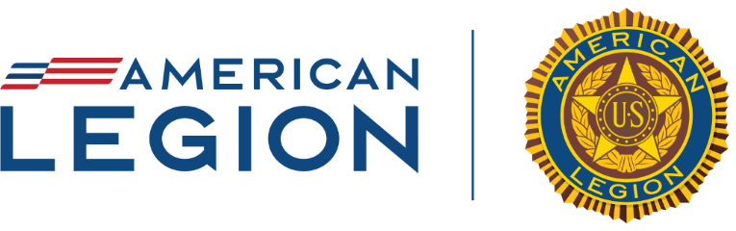

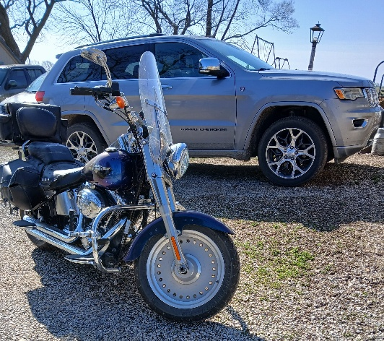

When: Saturday June 6th Registration starts at 9:30 A.M at McDonald’s, the two runs will start at 10:00 am. If rain is in the forecast, it will be cancelled. Please call 785-242-8471 or 785-248-1750 for more info.
Cost- $20 per motorcycle or vehicle.
Come Join Us to help support the Ottawa American Legion Post 60 and show your gratitude to all of America’s Veterans. Open not only to motorcycles, but all vehicles. There will be raffles. This year there are two runs, a short run of just over 100 miles and a 250+ (260) run to celebrate America’s 250th Anniversary. For more info call 785-242-8471 or 785-248-1750.

